ENCABEZADO
NUM.PAGINA
NUM.PAGINAS
PLANT GROWTH CONDITIONS
NEGRITA
SUBRAYADO
Fresh citrus seeds of two citrus species, sour orange (Citrus aurantium L) and macrophylla (Citrus macrophylla Wester) were germinated in vermiculite wetted with a solution of 0.5 mM of CaSO₄ at 29°C. After 15-20 days in the dark, seedlings were transferred into buckets containing continuously aerated nutrient solution with the following composition: 6 mM KNO₃, 4 mM Ca(NO₃)₂·4H₂O, 2 mM NH₄H₂PO₄, 1 mM MgSO₄·7H₂O, 25 μM H₃BO₃, 2 μM MnSO₄·H₂O, 2 μM ZnSO₄·7H₂O, 0.5 μM CuSO₄·5H₂O, 0.065 μM (NH₄)₆Mo₇O₂₄·4H₂O and 40 μM Fe³⁺-masquolate. The pH was adjusted daily to 6-6.5. Plants were grown in a controlled chamber with a day/night cycle of 16/8 h, a 60/85 % relative humidity and 25/18 °C temperature, respectively.
After 1 month of adaptation to growth solution, 125 uniform seedlings with a total weight of 0.4-0.5 g and a root length of 8 cm were transferred to individual glass tubes containing nutrient solution supplemented with different concentrations of NaCl. Each glass tube was:
SUBINDICE
SANGRADO
CURSIVA
CENTRADO
- Protected from light.
SIMBOLOS
- Provided with constant aeration to ensure optimal oxygenation of the roots.
- Separated in 5 groups of 25 seedlings were established to separate saline treatments.
- Filled with saline solutions prepared by adding concentrated NaCl (5 M) to nutrient solutions in the glass tubes.
INTERLINEA
- Progressively prepared in fractions of 20 mM every 12 h to avoid osmotic shock
NUM. Y VIÑETAS
- Final NaCl concentration were:
  - 1 mM (considered as control)
  - 10 mM (considered as low salinity)
NUM. Y VIÑETAS 2º NIVEL
  - 20 mM (considered as low to moderate salinity)
  - 30 mM (considered as moderate to high salinity)
  - 60 mM (considered as high salinity)
SANGRADO
- Placed on a controled chambert for optimal growth

The addition of NaCl was considered as the initiation of the experiment (t= 0), and two plants were harvested and processed as control for each saline treatment. Three plants were harvested every 50-60 h from the beginning of the salinization until a maximum of 14 days of exposure. The remaining plants were weighted, and the length of the stem and root measured each time, then restored to its glass tubes.
TIPO LETRA
SANGRADO
The roots were cut up in four fragments: A. 0.5 cm from root tip; B, 1cm; C, 3 cm and D (variable length, 3 to 5 cm), and the shoots were separated in E (stems) and F (leaves). Each fragment was cut up into pieces of 1 mm long and digested with 1 ml of acetic acid 100 mM at 90°C as described before (Yeo and Flowers 1985). Supernatant was stored at -20°C until ionic determinations.
NOTA AL PIE
JUSTIFICADO
Analysis of Na⁺ and K⁺ was performed by atomic emission spectrometry. For the determination of Cl⁻, an aliquot of the acetic digestion was frozen and lyophilized for 12 h, resuspended in deionized water and analyzed by ionic chromatography in a DIONEX model D100 equipped with a Ionpac AS12A 4 mm (10-32) column. Cl⁻ was detected by conductivity and quantified by comparing peak areas with known standards.
NOTA AL PIE
PIE PAGINA
SUPERINDICE
BORDES
The net uptake rate and transport to the shoot were calculated using the formula:
${\text{net}}_{{\text{ion}}_{\text{uptake}}}=\frac{(\text{ln}R2−\text{ln}R1)}{(R2−R1)}\frac{(CT2−CT1)}{(t2−t1)}$ (μmol·g⁻¹·d⁻¹)
FORMULAS
$\text{transport}=\frac{(\text{ln}R2−\text{ln}R1)}{(R2−R1)}\frac{(CS2−CS1)}{(t2−t1)}$(μmol·g⁻¹·d⁻¹)
where R is the root dry weight, C_{T} is the total ion content (Cl⁻ or Na⁺) of the whole plant, and Cs is the ion content of the shoot, in two consecutive harvests (t₁ and t₂).
 | Na⁺ |  | K⁺ |  | Ca²⁺ |  | Cl⁻
Treatment  TABLAS  (n=6) | SO | MA | SO | MA | SO | MA | SO | MA
Control | 5 a | 2 a | 186 a | 203 a | 195 a | 82 a | 14 a | 12 a
Na⁺ | 86 b | 50 b | 129 b | 193 a | 144 b | 76 a | 14 a | 11 ab
NaCl | 111 c | 48 b | 122 b | 190 a | 164 ab | 80 a | 128 b | 75 c
Cl⁻ | 7 a | 4 a | 234 c | 249 b | 177 ab | 92 a | 163 c | 112 d
Macronut.  BORDES | 10 a | 17 a | 238 c | 354 c | 186 a | 146 b | 7 a | 7 b

Species
(n=30)
SO | 44 |  | 182 |  | 173 |  | 65
MA | 24 |  | 238 |  | 95 |  | 44
 |  |  | ANOVA | (F-values)
Specie | 32*** |  | 52*** |  | 194*** |  | 261***
Treatment | 93*** |  | 47*** |  | 11*** |  | 1632***
Spe x treatm | 14*** |  | 6** |  | 5** |  | 86***
The same letter in each column, indicates that there are not significant differences among treatments at 5% probability level, according to the Multiple Range Tukey Test. *,**,*** and ns represent p<0.05, 0.01, 0.001 and not significant, respectively.
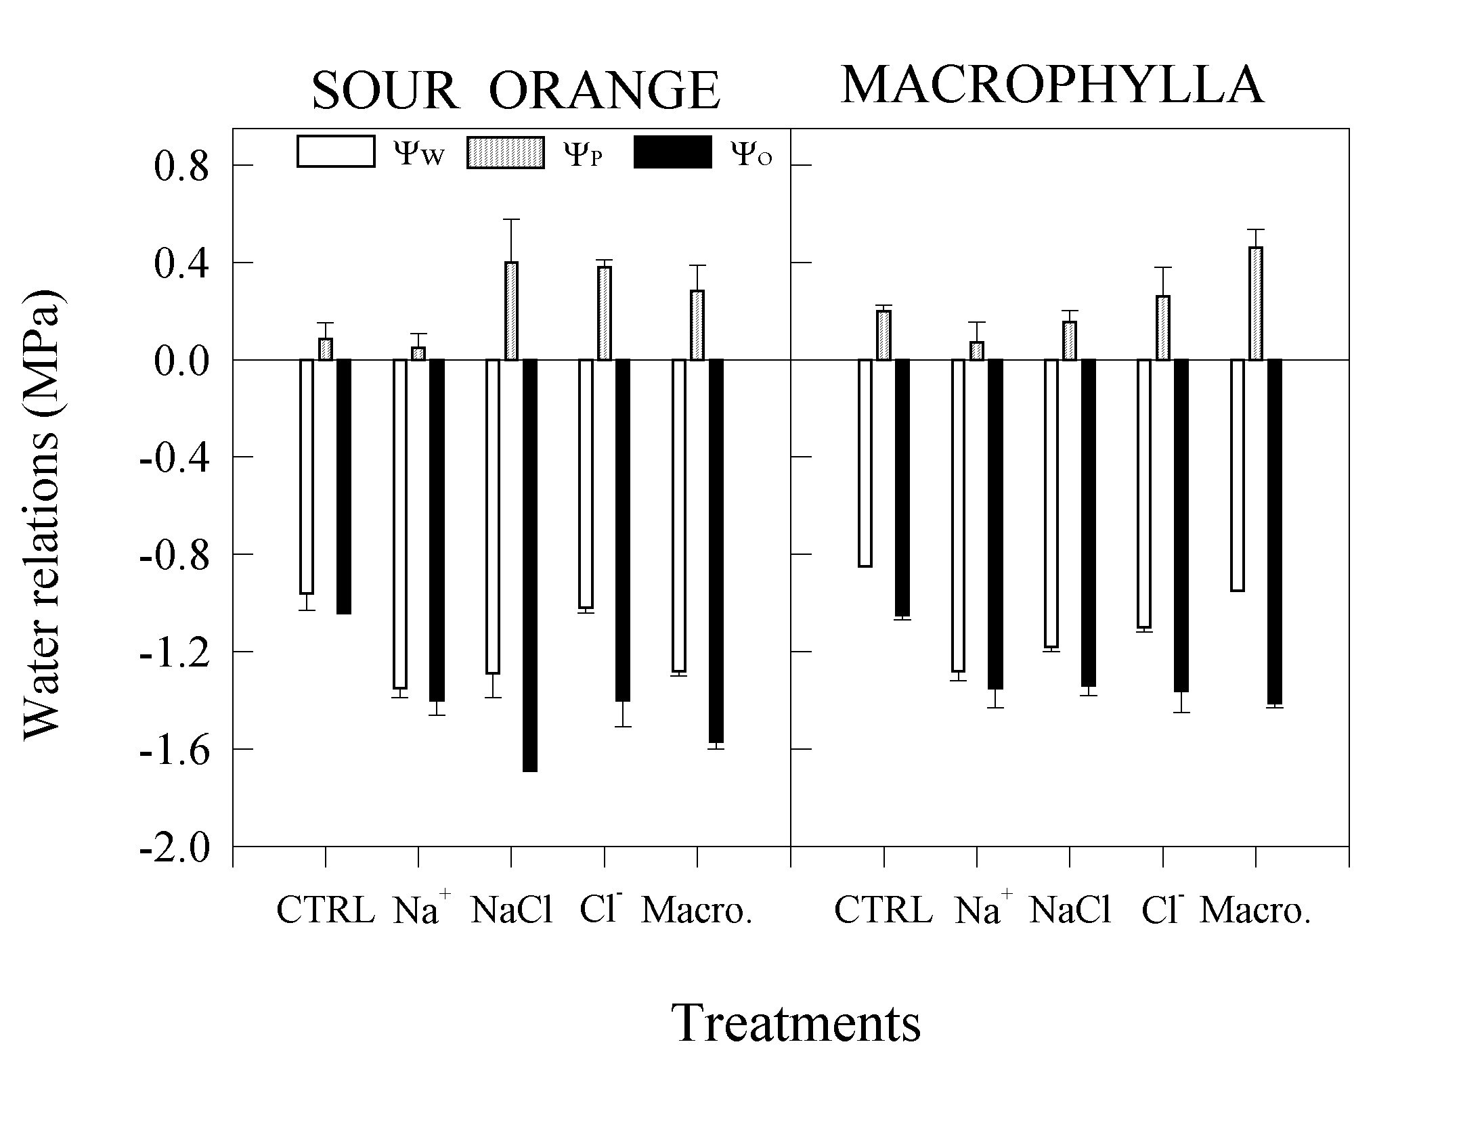
GRAFICOS
DIBUJOS/FOTOS

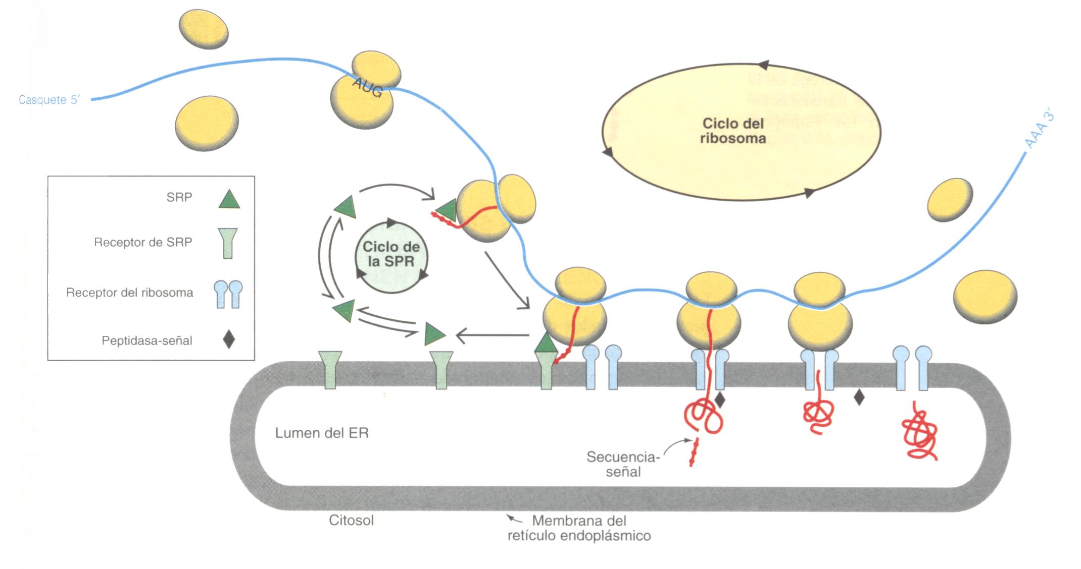

Harvested plants were rinsed in water and immediately processed as shown in Fig. 1.
The remaining solid materials from extraction were frozen and lyophilized for approximate determination of dry weight.

